WPL CCP
Instructor: Sir Faraz Abdul Basit

Name: Muhammad Sufyan Siddiqui
ID: IU04-0122-0391

Department: Computer Science Program: BS (CS)
WPL (Theory)
Announced date: 15-Jan-2026 |  |  | Due Date: 22-Jan-2026 |  | Total Marks = 10
 | Complex Computing Problem (CCP)
 | Mapped CLO | SDG |  | Complex Problem Solving Mapped
 | CLO3, GA4, C5 | 9 |  | WP3 (Depth of knowledge required)  WP1 (Range of conflicting requirements required)  WP2 (Depth of analysis required)

Title
Secure Design and Analysis of a Database-Driven Web Application Using SQL Injection Prevention Techniques

Problem Statement
A web-based system is being developed to manage user records through a relational database using MySQL. The system supports Create, Read, Update, and Delete (CRUD) operations through web forms.
However, such systems are highly vulnerable to SQL Injection attacks if user input is not properly validated and handled. Attackers can manipulate form inputs to execute unauthorized SQL commands, leading to data leakage, data corruption, or complete system compromise.
To ensure application security, the system must implement:
- Client-side input validation
- Server-side input validation
- Secure database interaction using prepared statements
Students are required to analyze, design, and justify a secure web-application workflow that prevents SQL injection while supporting complete CRUD functionality.

Constraints / Assumptions
- MySQL must be used as the database engine
- PHP must be used for server-side processing
- HTML, CSS, JavaScript, or jQuery may be used for frontend validation
- CRUD operations must be supported on at least one database table
- Prepared statements must be used for all database queries
- Input validation must be applied on both frontend and backend
- Focus is on security, design decisions, and analysis, not UI complexity

Expected Outcomes
Students must design, explain, and analyze a secure CRUD-based web system by completing the following tasks:

A. Threat Analysis and Problem Identification (2 Marks)
- Explain what SQL Injection is and how it occurs in web applications
- Identify vulnerable points in a typical form-based CRUD system

B. Frontend Validation Strategy (2 Marks)
- Propose suitable client-side validation techniques
- Explain how frontend validation improves usability and reduces invalid requests
- Discuss limitations of relying only on frontend validation

C. Backend Validation and Secure Query Design (3 Marks)
- Explain the role of server-side validation in security
- Describe how prepared statements prevent SQL injection
- Analyze how placeholders and parameter binding improve query safety

D. Secure CRUD Workflow Design (2 Marks)
- Design a logical flow for secure:
  - Insert
  - Select
  - Update
  - Delete
- Highlight where validation and prepared statements are applied in each operation

E. Security Evaluation and Best Practices (1 Mark)
- Identify one additional security measure (e.g., least privilege, error handling, input sanitization)
- Justify how it strengthens the system

Real-World Applicability
This CCP reflects real-world secure web systems such as:
- User registration and login systems
- Student management systems
- Online portals handling sensitive user data
- Database-driven enterprise web applications
- Secure CRUD-based administrative dashboards

Metric | Description
Conceptual Understanding | Understanding of SQL Injection and its risks
Technical Accuracy | Correct explanation of validation and prepared statements
Analytical Depth | Ability to analyze security flaws and countermeasures
Design Quality | Secure CRUD workflow design
Problem-Solving Efficiency | Handling conflicting requirements of usability and security

Deliverable:
Category | Deliverables
Conceptual | Explanation of SQL Injection and validation strategies
Design | Secure CRUD workflow diagrams / descriptions
Report | Written analysis of frontend validation, backend validation, and prepared statements

CCP Attributes mapped
Attributes of Complex Problem Solving |  |  |  | Justification
WP |  |  | Description | Theory of automata CCP Mapping
 | WP3 | Depth of Knowledge |  | Requires understanding of SQL Injection, prepared statements, and validation mechanisms
 | WP1 | Range of Conflicting Requirements |  | Balancing security, usability, and performance
 | WP2 | Depth of Analysis |  | Analysis of vulnerabilities, secure query design, and validation layers

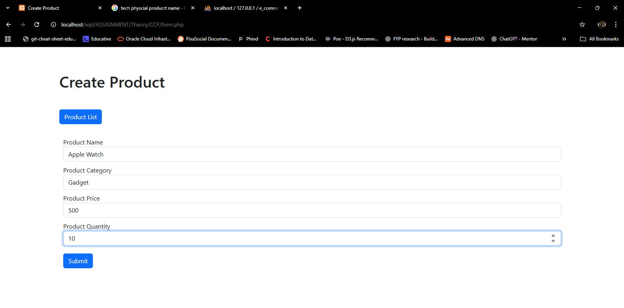
Screenshots:

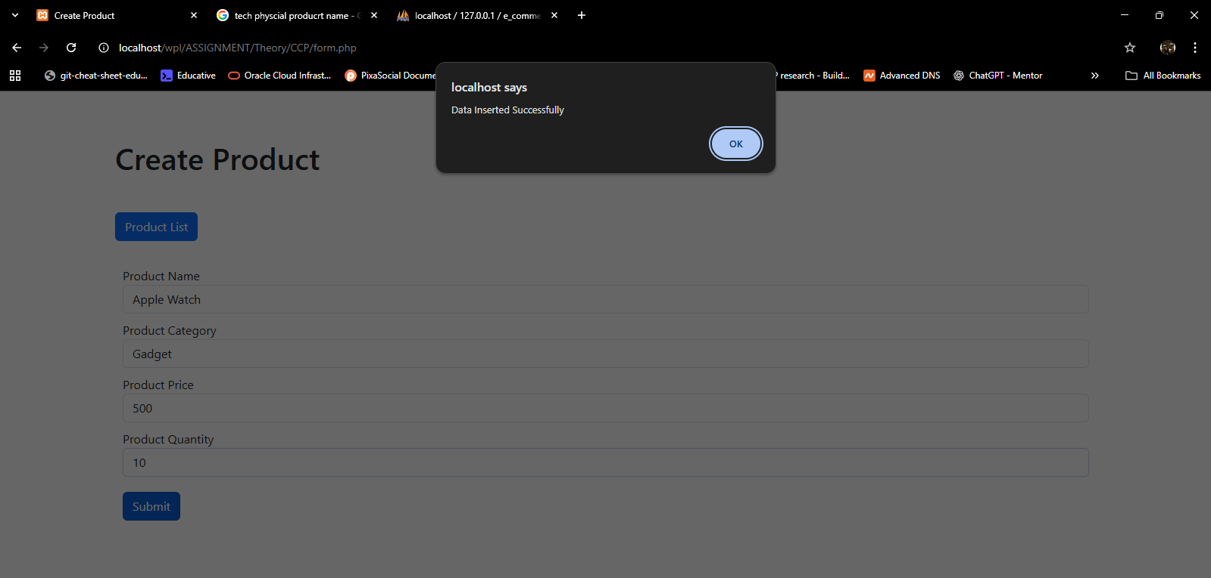

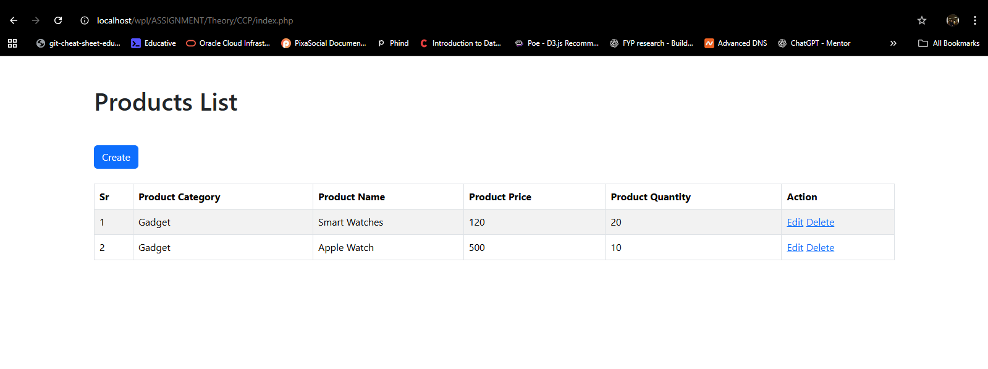
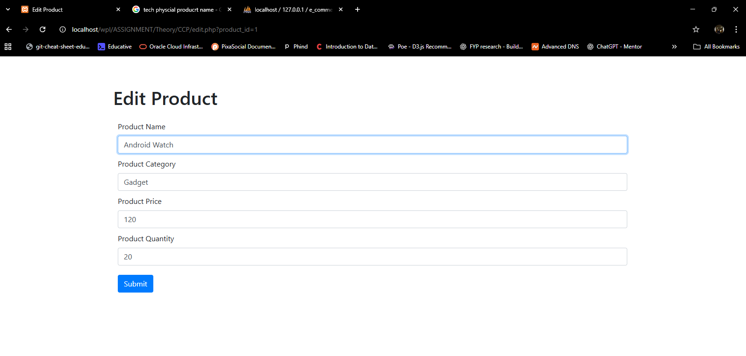
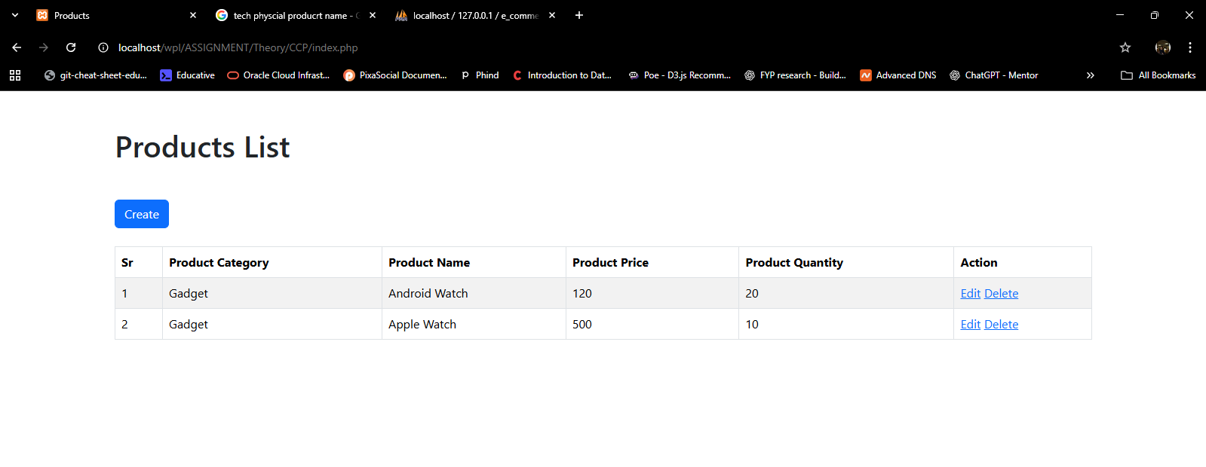

CODE:
Product list page:
<?php
$conn = mysqli_connect('localhost', 'root', '', 'e_commerce', '3307');

// Use prepared statement
$stmt = mysqli_prepare($conn, "SELECT * FROM products");
mysqli_stmt_execute($stmt);
$result = mysqli_stmt_get_result($stmt);
$data = mysqli_fetch_all($result, MYSQLI_ASSOC);
mysqli_stmt_close($stmt);
mysqli_close($conn);

?>
<!DOCTYPE html>
<html lang="en">

<head>
<meta charset="UTF-8">
<meta http-equiv="X-UA-Compatible" content="IE=edge">
<meta name="viewport" content="width=device-width, initial-scale=1.0">
<title>Products</title>
<script src="../../bootstrap/js/bootstrap.min.js"></script>
<link href="https://cdn.jsdelivr.net/npm/bootstrap@5.3.8/dist/css/bootstrap.min.css" rel="stylesheet"
integrity="sha384-sRIl4kxILFvY47J16cr9ZwB07vP4J8+LH7qKQnuqkuIAvNWLzeN8tE5YBujZqJLB" crossorigin="anonymous">

</head>

<body class="container mt-5">
<h1 class="my-4">Products List</h1>
<a href="form.php" class="btn btn-primary my-4">Create</a>

<table class="table table-bordered table-hover table-striped">
<thead>
<th>Sr</th>
<th>Product Category</th>
<th>Product Name</th>
<th>Product Price</th>
<th>Product Quantity</th>
<th>Action</th>
</thead>
<tbody>
<?php
for ($i = 0; $i < count($data); $i++) {
?>
<tr>
<td><?php echo $data[$i]['id'] ?></td>
<td><?php echo $data[$i]['product_category'] ?></td>
<td><?php echo $data[$i]['product_name'] ?></td>
<td><?php echo $data[$i]['product_price'] ?></td>
<td><?php echo $data[$i]['product_quantity'] ?></td>
<td>
<a href="edit.php?product_id=<?php echo $data[$i]['id'] ?>">Edit</a>
<a href="delete.php?product_id=<?php echo $data[$i]['id'] ?>">Delete</a>
</td>
</tr>
<?php
}
?>
</tbody>
</table>
</body>

</html>

Create Product:
<!DOCTYPE html>
<html lang="en">

<head>
<meta charset="UTF-8">
<meta http-equiv="X-UA-Compatible" content="IE=edge">
<meta name="viewport" content="width=device-width, initial-scale=1.0">
<title>Create Product</title>
<link href="https://cdn.jsdelivr.net/npm/bootstrap@5.3.8/dist/css/bootstrap.min.css" rel="stylesheet" integrity="sha384-sRIl4kxILFvY47J16cr9ZwB07vP4J8+LH7qKQnuqkuIAvNWLzeN8tE5YBujZqJLB" crossorigin="anonymous">
<script src="https://code.jquery.com/jquery-3.7.1.min.js"></script>

</head>

<body>
<div class="container mt-5 ">
<h1 class="py-3">Create Product</h1>
<a href="index.php" class="btn btn-primary my-4">Product List</a>

<form>
<div class="form-group" style="margin: 10px;">
<label for="">Product Name</label>
<input type="text" class="form-control" name="product_name" id="product_name" placeholder="Enter product name">
</div>
<div class="form-group" style="margin: 10px;">
<label>Product Category</label>
<input type="text" class="form-control" name="product_category" id="product_category" placeholder="Enter product category">
</div>
<div class="form-group" style="margin: 10px;">
<label>Product Price</label>
<input type="number" class="form-control" name="product_price" id="product_price" placeholder="Enter product price">
</div>
<div class="form-group" style="margin: 10px;">
<label>Product Quantity</label>
<input type="number" class="form-control" name="product_quantity" id="product_quantity" placeholder="Enter product quantity">
</div>

<input type="button" class="btn btn-primary" id="submitbutton" style="margin: 10px;" value="Submit">
</form>
</div>

<script>
// jQuery with Regex Validation
$(document).ready(function() {
$('#submitbutton').click(function(){
// Get values
var productName = $('#product_name').val().trim();
var productCategory = $('#product_category').val().trim();
var productPrice = $('#product_price').val();
var productQuantity = $('#product_quantity').val();

// Regex patterns
var nameRegex = /^[a-zA-Z0-9\s\-_]{3,100}$/;
var categoryRegex = /^[a-zA-Z0-9\s\-_]{3,50}$/;
var priceRegex = /^[0-9]+(\.[0-9]{1,2})?$/;
var quantityRegex = /^[0-9]+$/;

// Validate Product Name
if (productName === '') {
alert('Product name is required!');
return false;
}
if (!nameRegex.test(productName)) {
alert('Product name must be 3-100 characters and contain only letters, numbers, spaces, hyphens, or underscores!');
return false;
}

// Validate Product Category
if (productCategory === '') {
alert('Product category is required!');
return false;
}
if (!categoryRegex.test(productCategory)) {
alert('Product category must be 3-50 characters and contain only letters, numbers, spaces, hyphens, or underscores!');
return false;
}

// Validate Product Price
if (productPrice === '') {
alert('Product price is required!');
return false;
}
if (!priceRegex.test(productPrice) || parseFloat(productPrice) <= 0) {
alert('Product price must be a valid positive number!');
return false;
}

// Validate Product Quantity
if (productQuantity === '') {
alert('Product quantity is required!');
return false;
}
if (!quantityRegex.test(productQuantity) || parseInt(productQuantity) <= 0) {
alert('Product quantity must be a valid positive integer!');
return false;
}

// If all validations pass, submit data
let data = {
'product_name': productName,
'product_category': productCategory,
'product_price': productPrice,
'product_quantity': productQuantity
}

$.ajax({
type: 'POST',
url: 'forrmSubmit.php',
data: data,
success: function(response){
console.log(response);
var result = JSON.parse(response);
alert(result.msg);
if(result.code === '201') {
// Clear form on success
$('#product_name').val('');
$('#product_category').val('');
$('#product_price').val('');
$('#product_quantity').val('');
}
},
error: function() {
alert('Error submitting form!');
}
});
});
});
</script>
</body>

</html>

<?php
$conn = mysqli_connect('localhost', 'root', '', 'e_commerce', '3307');

// Get input values
$product_name = isset($_POST['product_name']) ? trim($_POST['product_name']) : '';
$product_category = isset($_POST['product_category']) ? trim($_POST['product_category']) : '';
$product_price = isset($_POST['product_price']) ? trim($_POST['product_price']) : '';
$product_quantity = isset($_POST['product_quantity']) ? trim($_POST['product_quantity']) : '';

// Regex validation in PHP
$nameRegex = '/^[a-zA-Z0-9\s\-_]{3,100}$/';
$categoryRegex = '/^[a-zA-Z0-9\s\-_]{3,50}$/';
$priceRegex = '/^[0-9]+(\.[0-9]{1,2})?$/';
$quantityRegex = '/^[0-9]+$/';

// Validate inputs
if (empty($product_name) || !preg_match($nameRegex, $product_name)) {
$response['msg'] = 'Invalid product name!';
$response['code'] = '400';
echo json_encode($response);
exit();
}

if (empty($product_category) || !preg_match($categoryRegex, $product_category)) {
$response['msg'] = 'Invalid product category!';
$response['code'] = '400';
echo json_encode($response);
exit();
}

if (empty($product_price) || !preg_match($priceRegex, $product_price) || $product_price <= 0) {
$response['msg'] = 'Invalid product price!';
$response['code'] = '400';
echo json_encode($response);
exit();
}

if (empty($product_quantity) || !preg_match($quantityRegex, $product_quantity) || $product_quantity <= 0) {
$response['msg'] = 'Invalid product quantity!';
$response['code'] = '400';
echo json_encode($response);
exit();
}

// Use prepared statement to prevent SQL injection
$stmt = mysqli_prepare($conn, "INSERT INTO products(product_name, product_category, product_price, product_quantity) VALUES (?, ?, ?, ?)");
mysqli_stmt_bind_param($stmt, "ssdi", $product_name, $product_category, $product_price, $product_quantity);

if(mysqli_stmt_execute($stmt)){
$response['msg'] = 'Data Inserted Successfully';
$response['code'] = '201';
echo json_encode($response);
}
else
{
$response['msg'] = 'Something went wrong';
$response['code'] = '500';
echo json_encode($response);
}

mysqli_stmt_close($stmt);
mysqli_close($conn);

Edit Product:
<?php
// Validate product_id
$id = isset($_GET['product_id']) ? intval($_GET['product_id']) : 0;

if ($id <= 0) {
die('Invalid product ID!');
}

$conn = mysqli_connect('localhost', 'root', '', 'e_commerce', '3307');

// Use prepared statement to prevent SQL injection
$stmt = mysqli_prepare($conn, "SELECT * FROM products WHERE id = ?");
mysqli_stmt_bind_param($stmt, "i", $id);
mysqli_stmt_execute($stmt);
$result = mysqli_stmt_get_result($stmt);
$data = mysqli_fetch_all($result, MYSQLI_ASSOC);

mysqli_stmt_close($stmt);

if (empty($data)) {
die('Product not found!');
}

?>
<!DOCTYPE html>
<html lang="en">

<head>
<meta charset="UTF-8">
<meta http-equiv="X-UA-Compatible" content="IE=edge">
<meta name="viewport" content="width=device-width, initial-scale=1.0">
<title>Edit Product</title>
<script src="../../bootstrap/js/bootstrap.min.js"></script>
<link rel="stylesheet" href="../../bootstrap/css/bootstrap.min.css">
</head>

<body>
<div class="container mt-5">
<h1 class="py-3">Edit Product</h1>
<form method="post" action="editForrmSubmit.php" onsubmit="return validateEditForm()">
<div class="form-group" style="margin: 10px;">
<input value="<?php echo $data[0]['id']?>" type="hidden" class="form-control" name="product_id">
</div>
<div class="form-group" style="margin: 10px;">
<label for="">Product Name</label>
<input value="<?php echo $data[0]['product_name']?>" type="text" class="form-control" name="product_name" id="product_name" placeholder="Enter product name">
</div>
<div class="form-group" style="margin: 10px;">
<label>Product Category</label>
<input value="<?php echo $data[0]['product_category']?>" type="text" class="form-control" name="product_category" id="product_category" placeholder="Enter product category">
</div>
<div class="form-group" style="margin: 10px;">
<label>Product Price</label>
<input value="<?php echo $data[0]['product_price']?>" type="number" class="form-control" name="product_price" id="product_price" placeholder="Enter product price">
</div>
<div class="form-group" style="margin: 10px;">
<label>Product Quantity</label>
<input value="<?php echo $data[0]['product_quantity']?>" type="number" class="form-control" name="product_quantity" id="product_quantity" placeholder="Enter product quantity">
</div>

<input type="submit" class="btn btn-primary" style="margin: 10px;" value="Submit">
</form>
</div>

<script>
function SubmitForm() {
var firvalidateEditForm() {
// Get values
var productName = document.getElementById('product_name').value.trim();
var productCategory = document.getElementById('product_category').value.trim();
var productPrice = document.getElementById('product_price').value;
var productQuantity = document.getElementById('product_quantity').value;

// Regex patterns
var nameRegex = /^[a-zA-Z0-9\s\-_]{3,100}$/;
var categoryRegex = /^[a-zA-Z0-9\s\-_]{3,50}$/;
var priceRegex = /^[0-9]+(\.[0-9]{1,2})?$/;
var quantityRegex = /^[0-9]+$/;

// Validate Product Name
if (productName === '') {
alert('Product name is required!');
return false;
}
if (!nameRegex.test(productName)) {
alert('Product name must be 3-100 characters and contain only letters, numbers, spaces, hyphens, or underscores!');
return false;
}

// Validate Product Category
if (productCategory === '') {
alert('Product category is required!');
return false;
}
if (!categoryRegex.test(productCategory)) {
alert('Product category must be 3-50 characters and contain only letters, numbers, spaces, hyphens, or underscores!');
return false;
}

// Validate Product Price
if (productPrice === '') {
alert('Product price is required!');
return false;
}
if (!priceRegex.test(productPrice) || parseFloat(productPrice) <= 0) {
alert('Product price must be a valid positive number!');
return false;
}

// Validate Product Quantity
if (productQuantity === '') {
alert('Product quantity is required!');
return false;
}
if (!quantityRegex.test(productQuantity) || parseInt(productQuantity) <= 0) {
alert('Product quantity must be a valid positive integer!');
return false;
}

return true;
</script>
</body>

</html>

<?php

$conn = mysqli_connect('localhost', 'root', '', 'e_commerce', '3307');

// Get and validate input values
$id = isset($_POST['product_id']) ? intval($_POST['product_id']) : 0;
$product_name = isset($_POST['product_name']) ? trim($_POST['product_name']) : '';
$product_category = isset($_POST['product_category']) ? trim($_POST['product_category']) : '';
$product_price = isset($_POST['product_price']) ? trim($_POST['product_price']) : '';
$product_quantity = isset($_POST['product_quantity']) ? trim($_POST['product_quantity']) : '';

// Regex validation in PHP
$nameRegex = '/^[a-zA-Z0-9\s\-_]{3,100}$/';
$categoryRegex = '/^[a-zA-Z0-9\s\-_]{3,50}$/';
$priceRegex = '/^[0-9]+(\.[0-9]{1,2})?$/';
$quantityRegex = '/^[0-9]+$/';

// Validate inputs
if ($id <= 0) {
die('Invalid product ID!');
}

if (empty($product_name) || !preg_match($nameRegex, $product_name)) {
die('Invalid product name!');
}

if (empty($product_category) || !preg_match($categoryRegex, $product_category)) {
die('Invalid product category!');
}

if (empty($product_price) || !preg_match($priceRegex, $product_price) || $product_price <= 0) {
die('Invalid product price!');
}

if (empty($product_quantity) || !preg_match($quantityRegex, $product_quantity) || $product_quantity <= 0) {
die('Invalid product quantity!');
}

// Use prepared statement to prevent SQL injection
$stmt = mysqli_prepare($conn, "UPDATE products SET product_name = ?, product_category = ?, product_price = ?, product_quantity = ? WHERE id = ?");
mysqli_stmt_bind_param($stmt, "ssdii", $product_name, $product_category, $product_price, $product_quantity, $id);
mysqli_stmt_execute($stmt);
mysqli_stmt_close($stmt);
mysqli_close($conn);

header('Location: index.php');
exit();

Delete product:
<?php
// Validate product_id
$id = isset($_GET['product_id']) ? intval($_GET['product_id']) : 0;

if ($id <= 0) {
die('Invalid product ID!');
}

$conn = mysqli_connect('localhost', 'root', '', 'e_commerce', '3307');

// Use prepared statement to prevent SQL injection
$stmt = mysqli_prepare($conn, "DELETE FROM products WHERE id = ?");
mysqli_stmt_bind_param($stmt, "i", $id);
mysqli_stmt_execute($stmt);
mysqli_stmt_close($stmt);
mysqli_close($conn);

header('Location: index.php');
exit();

